$250 REWARD
For Information Leading to Return
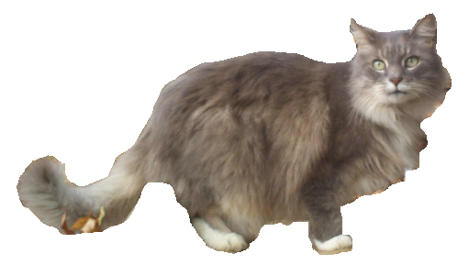
Escaped Indoor-Only Cat
Long-Haired, Gray with White Chest & Paws
Shy – Do Not Chase! Call Anytime:
413-539-3530
lostpetresearch@gmail.com
Last Seen October 20 – 18th St. & 2nd Ave.

Please take a photo of this flyer with your cell phone so you’ll have it on-hand

